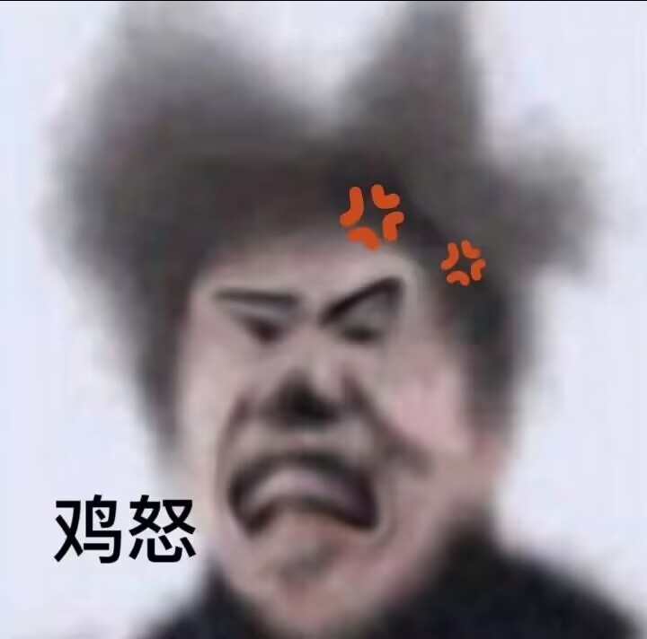
flag藏哪了？？？！
cGFzc3dvcmTvvJppa3VuaWt1bg==

